**View State:**

<https://www.c-sharpcorner.com/UploadFile/225740/what-is-view-state-and-how-it-works-in-Asp-Net53/>

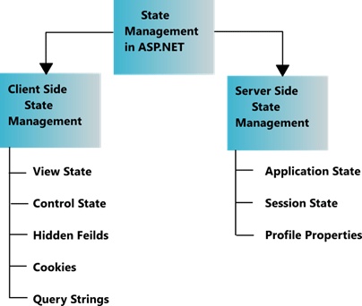

**Session:**

<https://www.guru99.com/asp-net-session-management.html>

Difference Between View State and Session:

* Session management is a way in ASP.net to ensure that information is passed over from one page to the other.
* The view state property of a page is used to **automatically** pass the information of controls from one page to the other.
* The 'Session' object is used to store and retrieve **specific** values within a web page.

**IIS(web server)**

Internet Information Server (IIS) is one of the most popular web servers from Microsoft that is used to host and provide Internet-based services to ASP.NET and ASP Web applications. A web server is responsible for providing a response to requests that come from users. When a request comes from client to server IIS takes that request from users and process it and send response back to users.

**Global.asax**

Global.asax is an optional file which is used to handling **higher level application events** such as Application_Start, Application_End, Session_Start, Session_End etc. It is also popularly known as ASP.NET

Postback:

<http://net-informations.com/faq/asp/postback.htm>

Response.Write() and **Response.Output.Write(** ):

<http://net-informations.com/faq/asp/write.htm>

# Passing values between Asp.Net pages

<http://net-informations.com/faq/asp/passing-values.htm>

# How many web.config files in Asp.Net?

# <http://net-informations.com/faq/asp/config.htm>

# User Input Validation in ASP.NET

# <http://net-informations.com/faq/asp/input.htm>